TEAMID: PNT2022TMID51917

Steps:

Create a Kubernetes cluster

* Sign in to your [IBM Cloud Dashboard.](https://cloud.ibm.com/dashboard/apps/?cm_sp=ibmdev-_-developer-tutorials-_-cloudreg)
* Open **IBM Kubernetes Service**.

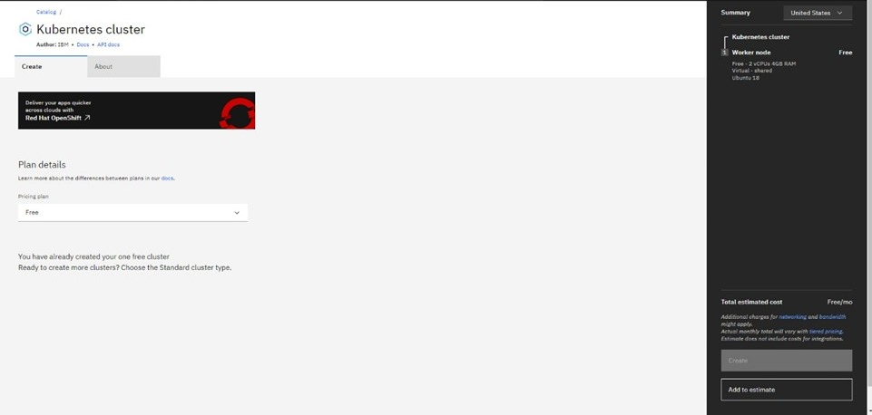

* Click Create Cluster.

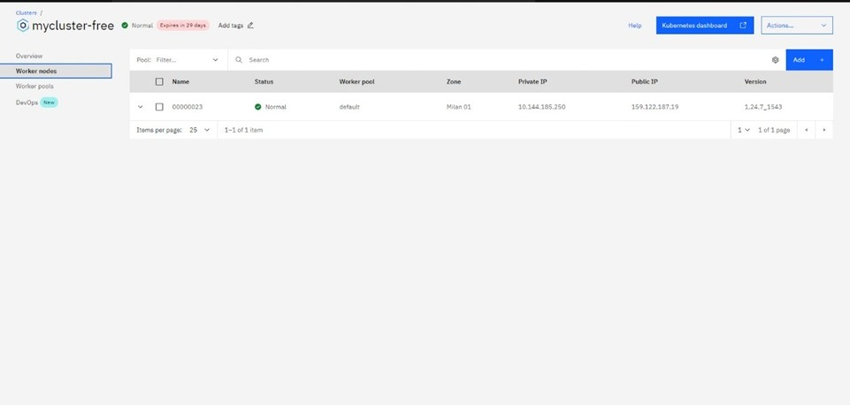

* Select the Region where you want to deploy the cluster, type in a name for your cluster, then click Create Cluster.
* Select the appropriate cluster type depending on your account.
* It takes some time for the cluster to get ready (around 30 minutes).
* Once the cluster is ready, click on your cluster's name and you will be redirected to a new page with information about your cluster and worker node.
* Click on the Worker Nodes tab to note the cluster's Public IP.